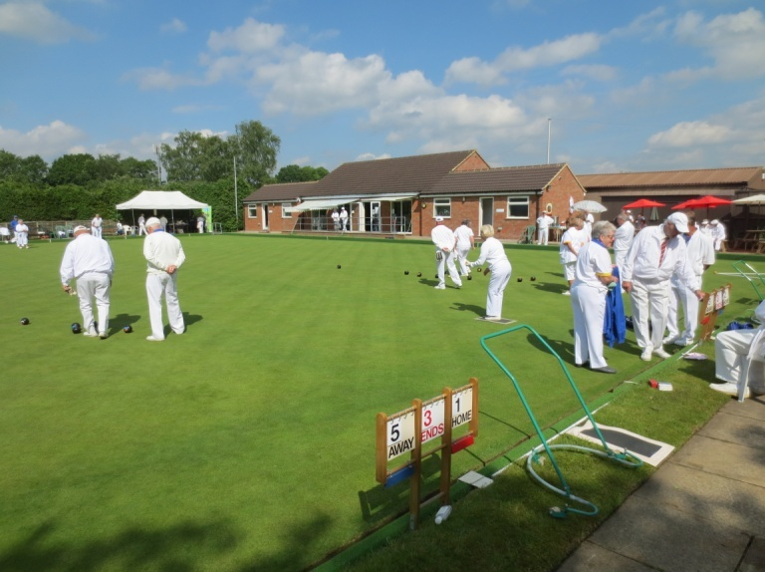
CHALFONT ST GILES BOWLING CLUB
This is the first of our regular weekly reports through the summer,
covering the period to April 29th

What a start to the season! Our Greens opened on April 18th, in time for members to practise in the fine weather over Easter, but were then faced with a very chilly first match at home to Rickmansworth British Legion on Saturday 28th. Played in cold and windy conditions, we still managed a win in this friendly encounter by 74 to 58 shots , to open our season.
Helped by our Top Rink of Chris Moir, Hubert Cox and Captain-of-the-Day George Ivey who won 35-8 against an opposing Captain who was supporting two new bowlers. Well done to both teams for playing and let’s hope the weather improves in the coming weeks.
Sunday brought better conditions, and a visit from Stoke Poges Bowling Club. We started encouragingly, being 11-6 up overall after 3 ends, but the run-in to the tea-break saw a resurgence by our opponents, who led 34-29 at the interval. The second half was close on all rinks, though Stoke Poges ran away at the end, winning by 69 - 48. Our closest result was by Tony Batkins, with Chris Moir and Colin Richards (14-15) , who were deemed to be our Top Rink, and well done for nearly clawing back despite losing a 7 at half way.
The first Friday roll-up and Baked Potatoes, was on Friday 26th, and a hardy 12 players risked the wet forecast and got away with it. Hopefully when the group of members currently touring in Spain will bring back some sunshine, and numbers will improve.
This was a promising start to the season, and whilst new members are always welcome to contact us at any time, please refer to our Website www.csgbowlingclub.co.uk and in particular note our Open Morning on May 4th, and our Open Day on June 10th, when members look forward to introducing all interested visitors, friends or family, to a day of Bowling, Fun Games and hopefully a BBQ , weather permitting.

