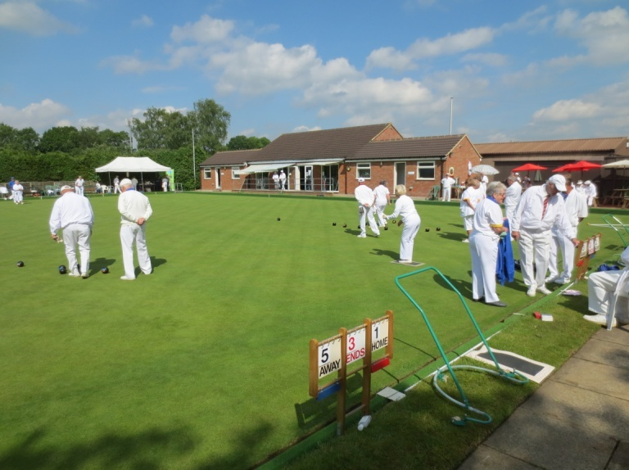
CHALFONT ST GILES BOWLING CLUB
This is the latest of our regular weekly reports through the summer,
covering the period to May 5th

The season is now well under way, the Internal Competitions have been drawn, and an Open Morning on May 4th saw a few potential prospects for new membership. The next Open Day is on June 9th, but if anyone is interested in getting started now, just contact us through the website, or any existing member.
On Tuesday April 30th, our first midweek friendly was against Court Park, on a fine warm afternoon, giving everyone a fine chance to consolidate their start to the season. At half-way the score was close, but leaning towards our visitors, but after tea we edged ahead to an overall win by 81-76. Top Rink was Rob Kirby, with Staff Burbridge and Chris Moir (25-11), but also notable was the recovery from 2-10 to 15-15 by Graham Buchanan, Mick Lane and Mike Wise. We look forward to our return game , when Court Park, currently having to all their matches play away till June, will have their new Clubhouse open.
On Wednesday 1st May , we played a friendly at home against Glory Mill, and after a mix-up on the number of triples due to be played had been sorted out, three Triples enjoyed a good afternoon's bowling. We managed two wins out of three, with Top Rink going to Candi Ivey, with Rob Kirby and Lyn Carroll (30-10), giving us an overall win by 64 -43.
We always enjoy playing this small club, and news that they are under notice of possible closure in the next couple of years is unfortunate. However, we look forward to further encounters this year, in the C&T league and another weekend friendly.
Apologies to the Ladies hoping to play, but Denham called off the friendly game on May 2nd, through lack of players.
On Saturday 4th May we played another friendly, this time against Hazells B C at home. Unfortunately, we suffered a defeat by 80 to 128 winning only one triple. This one team was therefore our Top Rink, with Maggie Pipe, Bob Baker and John Pink who won 20 to 18.
The weather was very variable with us having to stop at one point because of heavy hailstones, whilst generally it was raining and cold, but then the sun came out, to encourage us to come back next time !

